Practical 15

Aim: Client-Server Communication Model using TCP

Phase 1: Write the Server Code
The server will start up, bind to a specific port on your PC, and wait for a client to say hello.
- Create a folder on your Desktop named TCP_Practical.
- Open Notepad or your preferred IDE and paste the following code.
- Save the file as server.py.

import socket

def start_server():
# 1. Create a socket object (IPv4, TCP)
server_socket = socket.socket(socket.AF_INET, socket.SOCK_STREAM)

# Get local machine name/IP and reserve a port
host = '127.0.0.1' # Localhost
port = 12345 # Port to listen on

# 2. Bind the socket to the port
server_socket.bind((host, port))

# 3. Listen for incoming connections (max 5 queued connections)
server_socket.listen(5)
print(f"Server is listening on {host}:{port}...")

while True:
# 4. Accept a client connection
client_socket, client_address = server_socket.accept()
print(f"Connection established with {client_address}")

# 5. Receive data from the client (up to 1024 bytes)
data = client_socket.recv(1024).decode('utf-8')
print(f"Message from client: {data}")

# 6. Send a response back to the client
response = "Hello from the Server! Your message was received."
client_socket.send(response.encode('utf-8'))

# 7. Close the connection with this specific client
client_socket.close()
break # Remove this break to keep the server running continuously

if __name__ == '__main__':
start_server()

Phase 2: Write the Client Code
The client will execute, look for the server at the specified IP and port, establish a TCP connection, and send a message.
- In the same TCP_Practical folder, create a new file.
- Paste the following code.
- Save the file as client.py.

import socket

def start_client():
# 1. Create a socket object (IPv4, TCP)
client_socket = socket.socket(socket.AF_INET, socket.SOCK_STREAM)

# 2. Define the server's IP and Port to connect to
host = '127.0.0.1'
port = 12345

try:
# 3. Connect to the server
client_socket.connect((host, port))
print("Connected to the server successfully.")

# 4. Send a message to the server
message = "Hello Server, this is the Client!"
client_socket.send(message.encode('utf-8'))

# 5. Receive the response from the server
response = client_socket.recv(1024).decode('utf-8')
print(f"Message from server: {response}")

except ConnectionRefusedError:
print("Connection failed. Is the server running?")
finally:
# 6. Close the connection
client_socket.close()

if __name__ == '__main__':
start_client()

Phase 3: Run the Practical on PC
To see the communication happen in real-time, you need to run the server and the client simultaneously.
- Open two separate Command Prompt (cmd) windows.
- In both windows, navigate to your folder:

cd Desktop\TCP_Practical

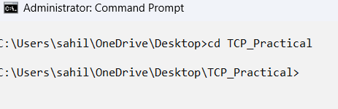
- In Window 1 (The Server): Type the following and press Enter. It will pause and wait.
python server.py
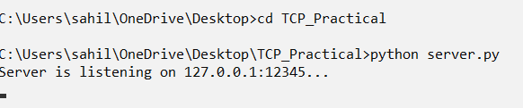
- In Window 2 (The Client): Type the following and press Enter.
python client.py
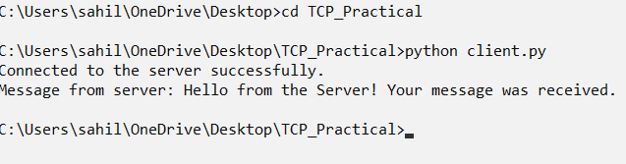
Output (Server Window):
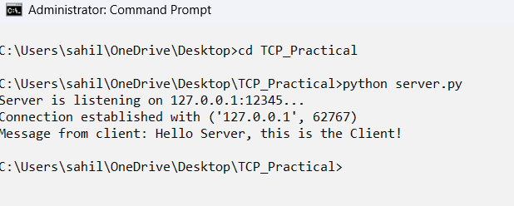
Output (Client Window):
